**Go to your OctoPrint Settings -> GCODE Scripts (Remove all the red statements before inserting in your printer.cfg!)**

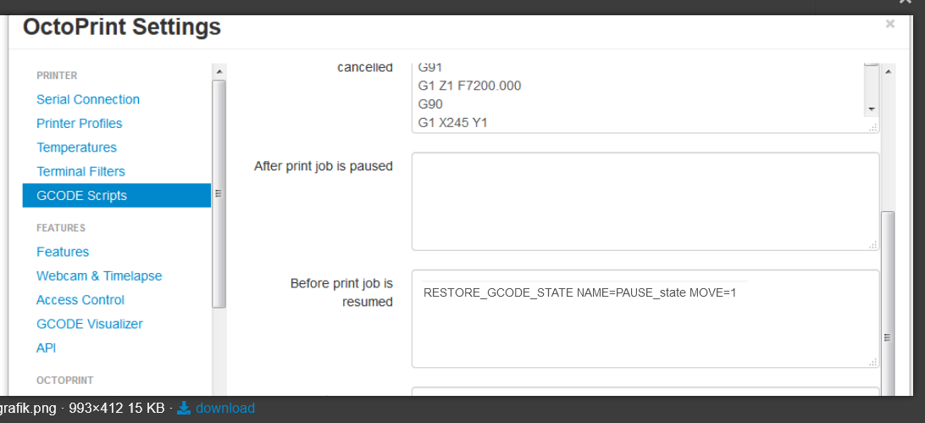

**Select – Before print job is resumed**

**Insert the following gcode**

RESTORE_GCODE_STATE NAME=PAUSE_state MOVE=1

**Put this code in your printer.cfg**

[idle_timeout]

gcode:

**I do not want to shutdown my extruder or the bed so there is NO Timeout**

[pause_resume]

recover_velocity: 50.

[gcode_macro M600]

gcode:

CLEAR_PAUSE

SAVE_GCODE_STATE NAME=PAUSE_state MOVE=1

[filament_switch_sensor my_sensor]

pause_on_runout: True

runout_gcode:

M600

G1 E-10 F150 /Retract 10mm Filament – switch with the next 2 rows if you want

G91 /Position (Important, sometime the nozzle goes down!

G1 Z20 F200 /Lift the nozzle 20mm

G92 E0 /Reset Extruder

G1 E-70 F150 /Retract 70mm (Change this for Bowden)

insert_gcode: / I am extruding new filament manually ,but you can insert whatever you want

event_delay: 3.0

pause_delay: 1.0

switch_pin: !ar2 /Change this to your pin!

**After inserting the new filament I am adding the filament with the octoprint extrude with 90mm filament and remove the filament leaving the nozzle, that is why I am not adding „Insert_gcode“**

Just press „resume print“ after inserting your new filament

To avoid extrusion error I added the following line in my printer.cfg

[extruder]   
max_extrude_only_distance: 1000.00

max_extrude_only_velocity: 120

max_extrude_only_accel: 3000

max_extrude_cross_section:10